TASK 2
Hands-On Data Lab Implementation
Building the environment and working through practical exercises
Data Science Internship Report
Submitted by: [Your Full Name]
November 2026

1. Overview
The goal of this task was twofold: get a proper data science environment running, and then prove it works by doing real data manipulation, visualisation and basic analysis. I treated the setup as part of the work rather than an afterthought, because a reproducible environment saves a huge amount of pain later. Everything here is available in the GitHub repository (scripts/task2_lab_tips.py).

2. Setting up the environment

2.1 Approach
I used an isolated virtual environment so that the libraries for this project do not clash with anything else on the machine, then installed the standard scientific stack and Jupyter for interactive work.
python -m venv ds-lab
source ds-lab/bin/activate # Windows: ds-lab\Scripts\activate
pip install pandas numpy matplotlib seaborn scipy scikit-learn jupyterlab
pip freeze > requirements.txt
jupyter lab

2.2 Versions used
Library | Version | Used for
Python | 3.12.3 | Core language
pandas | 3.0.2 | Tables and data manipulation
NumPy | 2.4.4 | Fast numerical arrays
Matplotlib | 3.10.8 | Base plotting
Seaborn | 0.13.2 | Statistical charts
SciPy | 1.17.1 | Statistical tests
scikit-learn | 1.8.0 | Modelling (later tasks)

Saving the exact versions to requirements.txt means anyone cloning the repository can rebuild the same setup with a single command. A quick import check at the top of each script confirmed everything loaded properly before I started analysing anything.

3. The dataset
I used the public "tips" dataset: 244 restaurant bills with 7 columns (total bill, tip, sex of payer, smoker, day, time and party size). It has 0 missing values and 1 fully duplicated row. I kept that one row on purpose: the data has no unique ID, so two identical bills could easily be two genuine, different tables.

4. Practical exercises

4.1 Data manipulation
I created two derived columns, tip percentage and bill per person, then practised filtering, grouping and pivoting.
df["tip_pct"] = df.tip / df.total_bill * 100
df["bill_per_person"] = df.total_bill / df["size"]
df[df.total_bill > 30] # filtering
df.groupby("day").tip_pct.mean() # grouping
df.pivot_table(index="day", columns="time", values="total_bill")
- Bills over $30: 32 of 244.
- Average tip: 16.08% (mean) and 15.48% (median) of the bill, so the typical diner tips just under the 16% mark.
Day | Bills | Avg bill | Avg tip | Avg tip %
Thur | 62 | $17.68 | $2.77 | 16.13%
Fri | 19 | $17.15 | $2.73 | 16.99%
Sat | 87 | $20.44 | $2.99 | 15.31%
Sun | 76 | $21.41 | $3.26 | 16.69%

Saturday is the busiest day in this data (87 bills) but has the lowest average tip percentage (15.31%). Friday has the highest (16.99%), but with only 19 bills I would not read much into it. I also noticed that the day-and-time pivot had zeros for weekend lunches. That is not a bug: there are simply no weekend lunch records, which is worth knowing before comparing lunch and dinner.

4.2 Grouped comparisons
- Smokers tipped 16.32% on average versus 15.93% for non-smokers, a very small gap.
- Female payers averaged 16.65% and male payers 15.76%.
- Lunch averaged 16.41% against 15.95% at dinner.
- Tip percentage falls as parties get bigger: 16.57% for two people, 15.21% for three and 14.59% for four. Parties of one, five and six have only 4 to 5 bills each, so those figures are unreliable.

4.3 Visualisation
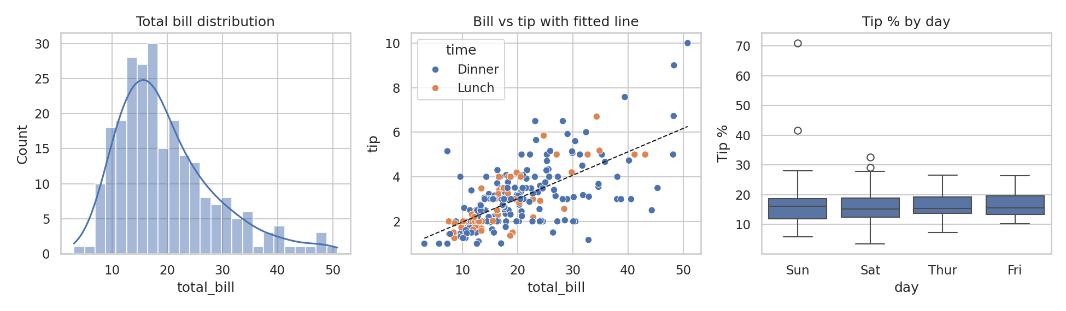
Figure 1. Bill distribution, bill vs tip with a fitted line, and tip % by day.
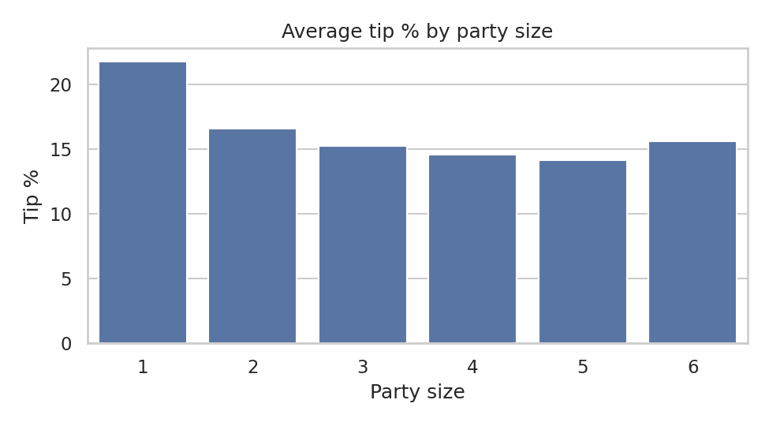
Figure 2. Average tip % by party size.
The histogram shows the bill distribution leaning to the right. The scatter plot shows a clear upward trend between bill and tip, with more spread as bills get larger. The boxplots show that tip percentage varies far more within a day than between days, which suggests day of the week is not a strong driver on its own.

4.4 Basic analysis
The correlation between bill and tip is 0.676, which is strong. But the correlation between the bill and the tip percentage is -0.339: larger bills get a smaller share as a tip. That fits the common habit of tipping less than proportionally on expensive meals.
To keep the maths visible, I fitted a straight line with NumPy's polyfit: tip ≈ 0.92 + 0.105 × bill, with R² = 0.457. In plain words, each extra dollar on the bill goes with about 11 cents more tip, and the bill alone explains roughly 46% of the variation in tips.

5. Pitfalls I watched for
- Overlapping axis labels made some charts unreadable at default sizes; a wider figure and tight_layout() fixed that.
- Group averages on very small groups look dramatic until you check the counts, so I printed group sizes next to every average.
- Newer pandas versions can store text columns differently from older ones, so I confirmed dtypes explicitly instead of assuming them.

6. Conclusion
The environment is stable, documented and reproducible, and the exercises covered the full small-scale workflow: load, inspect, transform, group, plot and interpret. The main lesson was to always look at sample sizes and context before trusting a pattern. The same toolkit is used in the larger analysis project and in the capstone.

